Generating UBLOX GPS Configuration Messages.

Some of the configurations for the UBLOX GPS require the creation of PUBX (ASCII) or PBX (binary) configuration messages.

You can work these out from the manual, with some difficulty, but you then need to work out what the checksums are.

There is a tool provided by UBLOX that will do all this for you, its called U-Centre, runs under Windows. I recommend you download and install it.

You can connect U-Centre it to a running GPS where you will be able to see all the information on satellites, signal strengths etc. You can also make configuration changes and test the effect.

This is an example of how to generate the power saving message, you don’t need the GPS connected to do this.

Start U-Centre
Select Receiver\Port\COM7 (if you have a GPS connected)
Select Receiver\Baud rate\9'600 (Default for UBLOX)
Select View\Message View (F9)
Pull up the binary message display, bottom centre and right as bellow
Scroll down to and click on UBX to expand the list, then on CFG
Scroll down and select RXM (Receiver Manager)
See screen shot below;

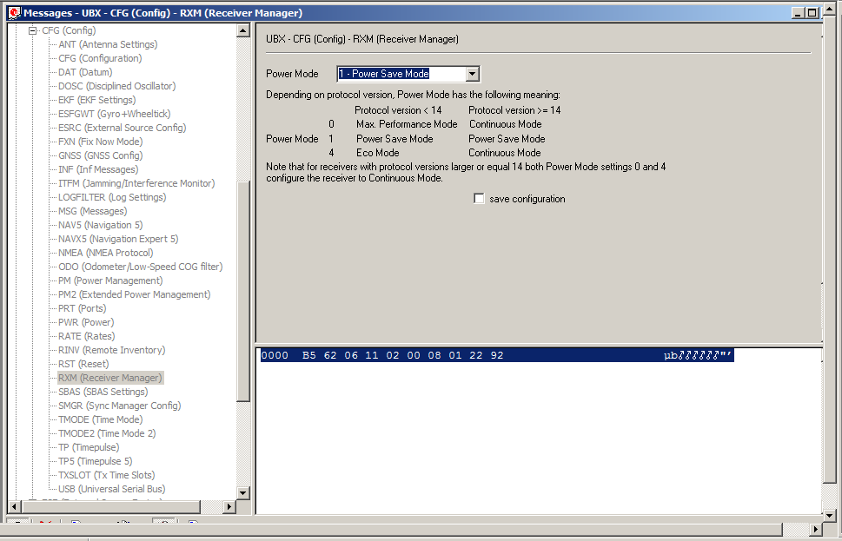

On the drop down box to the right of the messages list select;

'1 - Power Save Mode'

The message required to set power save mode is displayed in the window bottom right, the text of which is;

0000 B5 62 06 11 02 00 08 µb#####
0007 01 22 92 #"’

So the message to send for power save mode is;

$B5, $62, $06,$11,$02,$00,$08,$01,$22,$92

The last two bytes, $22 and $92 are the checksum bytes.

And in PICAXE Basic for instance this is done with this command;

hserout 0, ($B5, $62, $06, $11, $02, $00, $08, $01, $22, $92)

Stuart Robinson
November 2014

GLOSNASS Mode

The UBLOX MAX 8 powers up with GLOSNASS mode enabled, to make power saving mode work we need to disable this.

The configuration for setting the UBLOX 8 GPS from the default of GLOSNAS mode to normal GPS mode is;

Select View\Message View (F9)
Scroll down to and click on UBX to expand the list, then on CFG
Scroll down and select GNSS (GNSS Config)
See screenshot below;
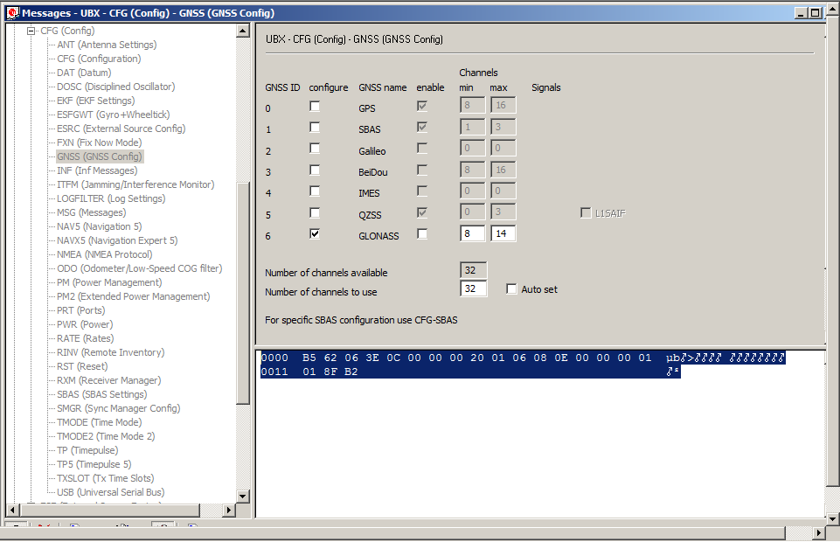
Clear the ticks from the 'configure' check boxes for all bar '6 GLONASS'.
Clear the tick from the 'enable' check box for '6 GLONASS'.

The message required to disable GLONASS mode is displayed in the window bottom right, the text of which is;

0000 B5 62 06 3E 0C 00 00 00 20 01 06 08 0E 00 00 00 01 µb#>#### ########
0011 01 8F B2 #²

So the message to disable GLONASS mode is;

$B5, $62, $06, $3E, $0C, $00, $00, $00, $20, $01, $06, $08, $0E, $00, $00, $00, $01, $01, $8F, $B2

The last two bytes, $8F and $B2 are the checksum bytes.

And in PICAXE Basic this is done with this command;

hserout 0, ($B5, $62, $06, $3E, $0C, $00, $00, $00, $20, $01, $06, $08, $0E, $00, $00, $00, $01, $01, $8F, $B2)

Stuart Robinson
GW7HPW
November 2014

\UBX\CFG\GNSS\

0000 B5 62 06 3E 0C 00 00 µb#>###
0007 00 00 01 00 00 00 00 #######
000E 01 00 00 01 53 B8 ####S¸

B5 62 06 3E 0C 00 00 00 00 01 00 00 00 00 01 00 00 01 53 B8

Stuart Robinson
GW7HPW
23rd November 2014

